**HOTEL DATABASE MANAGEMENT SYSTEM**

FINAL PROJECT REPORT

**Team Professor:** Abdullah Alenezi

**Team Members(Group 8) :**

Sravani Reddy Meda

Namratha Reddy Regalla

Sai Sruthi Thileti

Joshnavi Chenreddy

Ashwitha Eravelly

**DATABASE OVERVIEW:**

**OBJECTIVE:**

The Hotel Database Management System aims to provide a fully functional and offline automated system, with some online capabilities. Its primary objective is to offer a reliable and well-organized system with minimal errors. The system seeks customer feedback to demonstrate the hotel's commitment to its clients.

Customers have the convenience of creating an account from the comfort of their homes and logging in for their intended purposes. A centralized database has been implemented to address the challenges and flaws associated with the current manual approach while ensuring secure record-keeping. Executives can access information about room availability by logging in with their unique IDs.

The main goal of the Hotel Database Management System is to design and maintain comprehensive records of users and room details, including hotel bookings.

**SCOPE:**

There are several reasons to consider implementing a new computer-based hotel management system. One of the key advantages of the proposed solution is the elimination of laborious tasks for both customers and hotel executives when searching for and booking hotel rooms. The system will streamline these processes, making them more efficient.

The suggested solution will also benefit administrative personnel or hotel executives by providing accurate databases for maintaining daily and historical records of clients. Additionally, the system will generate appropriate reports for customers upon check-out. Despite its advanced capabilities, the system is designed to be user-friendly, even for new users.

Once implemented, the hotel management system will enable remote access to the hotel database, allowing authorized individuals to retrieve information and perform various functions from anywhere. Customers will have the ability to search for available rooms, make reservations, and provide feedback or reviews on their experiences.

**USER REQUIREMENTS:**

The hotel management system faces significant challenges when it comes to retrieving customer booking data. The system struggles to access and display all the necessary customer details along with their reservation information. As a result, it becomes difficult to track bookings, reservations, and guest information effectively. This hinders the hotel's ability to manage inventory and pricing efficiently.

Implementing a robust database can address these issues by providing a comprehensive view of customer records and their corresponding reservation details. With improved access to data, the hotel management system can track bookings more accurately, manage reservations effectively, and maintain updated guest information. Additionally, the database can offer valuable insights into customer trends and behaviors, enabling the hotel to make informed decisions and improve customer satisfaction.

**BUSINESS RULES:**

1. Each customer has the option to make multiple bookings.
2. A single customer can only make one reservation at a time.
3. Employees have the flexibility to enter zero or more bookings.
4. Each reservation can only be entered by one employee.
5. Customers are allowed to make one or more payments.
6. Only one customer can make a payment at a given time.
7. Each reservation for a room can have one and only one associated payment.
8. A payment can be linked to one or more reservations for rooms.
9. Each reservation is assigned to a specific room.
10. A room can be part of one or more bookings but cannot be assigned to multiple room reservations simultaneously.
11. Room reservations can only be entered into the system by designated staff.

**ENTITY RELATIONSHIP DIAGRAM:**

**DATA DICTIONARY:**

|  |  |  |  |  |
| --- | --- | --- | --- | --- |
| **TABLE NAME** | **ATTRIBUTE NAME** | **DATA TYPE** | **PRIMARY KEY REQUIRED** | **FOREIGN KEY REQUIRED** |
| USERS | user_id  first_name  last_name  email  phone_number  location | int  varchar  varchar  Varchar  int  varchar | user_id |  |
| RESERVATION | reservation_id  hotel_id  user_id  room_id | int  int  int  int | reservation_id | user id |
| room | room_id  hotel_id  Capacity  Price  reservation_id | Int  Int  Int  Double  Int |  | reservation_id |
| Hotel | hotel_id  hotel_name  location  reservation id | int  varchar  varchar  int |  | reservation_id |
| PAYMENT | user_id  reservation_id  transaction_status  payment_type | int  int  varchar  varchar |  | reservation_id |
| transaction | reservation_id  user_id  transaction_status | int  int  varchar |  | reservation_id |
| Emp loyees | Employees_id  Employee_name  Hotel_id  Reservation_id | int  varchar  int  int |  | reservation_id |
| Room_type | Room_name  Room_rating  Reservation_id | Varchar  Int  Int |  | Reservation_id |

**Creating the Database “HotelBookings”**

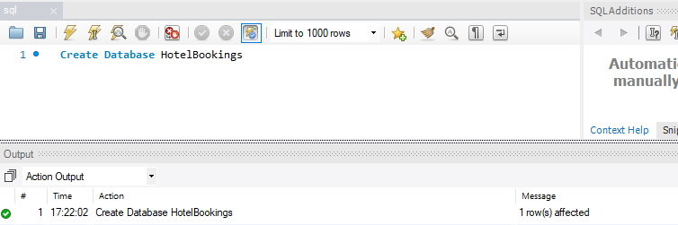

**Using Database HotelBookings**

**Creating “User” table:**

create table user(

user_id int,

first_namevarchar(15),

last_namevarchar(15),

email varchar(30),

phone_number int,

location varchar(15),

primary key (user_id)

);

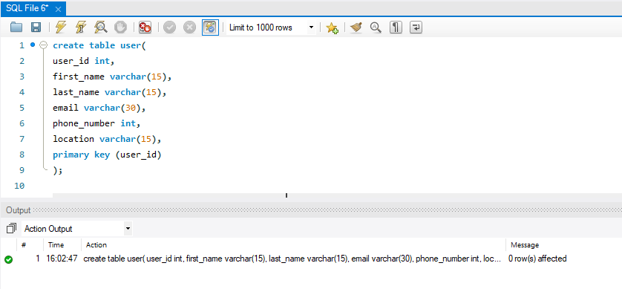**Inserting Values Into “User” table:**

Insert into user value(1001,'James','Robert','jRobert3@gmail.com',2345678,'Austin');

Insert into user value(1002,'Swetha','Goli','gswetha@gmail.com',1234567,'Austin');

Insert into user value(1003,'Liki','tha','likitha@gmail.com',0987654,'Arlington');

Insert into user value(1004,'Bindu','hh','Bindu@gmail.com',76654097,'Houston');

Insert into user value(1005,'John','Michael','John@gmail.com',8568946,'Irving');

Insert into user value(1006,'David','William','William@gmail.com',2309764,'clevland');

Insert into user value(1007,'Richard','Barbara','Barbara@gmail.com',5568790,'Irving');

Insert into user value(1008,'Anabella','Susan','Susan@gmail.com',7468536,'Coppel');

Insert into user value(1009,'Jessica','Sarah','Sarah@gmail.com',6479075,'Coppel');

Insert into user value(1010,'Margaret','Donaldson','Donaldson@gmail.com',8753689,'Houston');

Insert into user value(1011,'Sandra','Mark','V22Sandra@gmail.com',3399775,'Houston');

Insert into user value(1012,'Ashley','Steven','Steven@gmail.com',3300998,'San Antonio');

Insert into user value(1013,'Amanda','Brian','Brian@gmail.com',9468027,'Laredo');

Insert into user value(1014,'Jeffrey','Laura','Laura@gmail.com',4498765,'Laredo');

Insert into user value(1015,'Timothy','George','Timothy@gmail.com',0685356,'Laredo');

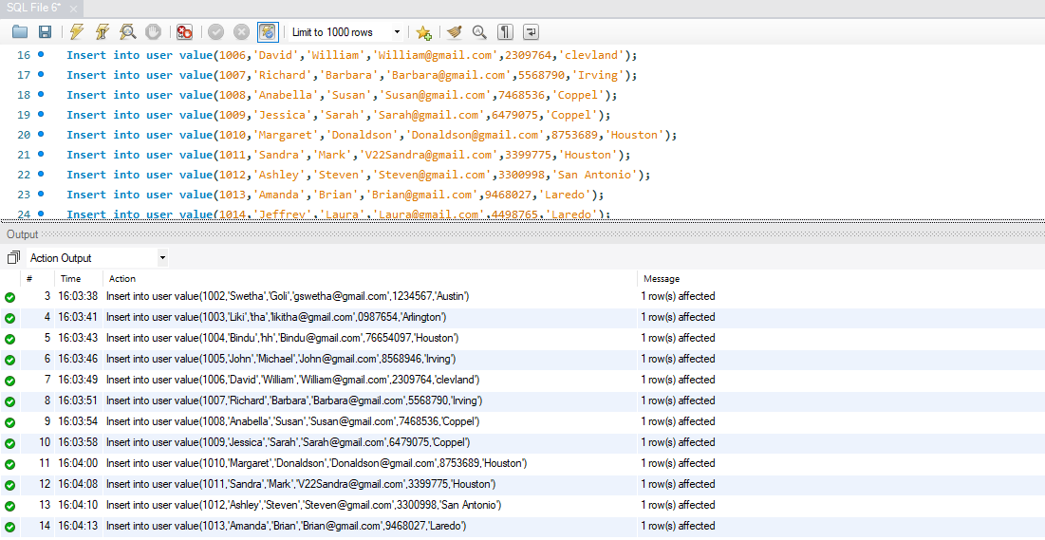

**Creating “Reservation” table:**

create table reservation

(

reservation_id int,

hotel_id int,

user_id int,

room_id int,

primary key(reservation_id),

FOREIGN KEY (user_id) REFERENCES user (user_id)

);

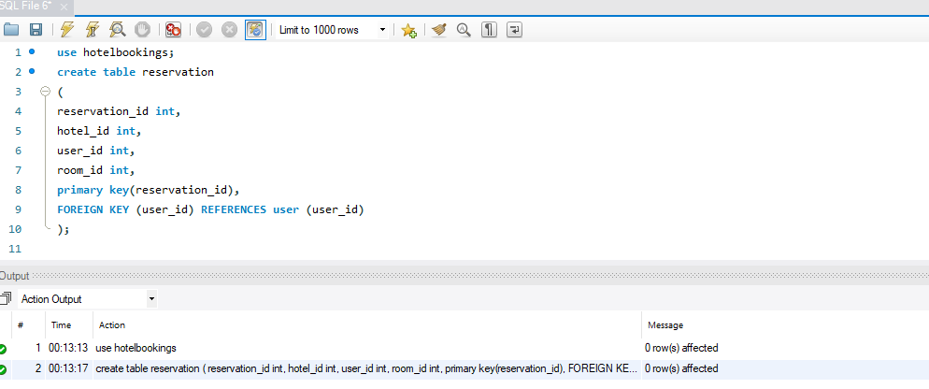

**Inserting values into “Reservation” table:**

Insert into reservation value(1789,888,1001,171);

Insert into reservation value(2637,888,1002,172);

Insert into reservation value(3227,888,1003,173);

Insert into reservation value(4778,888,1004,174);

Insert into reservation value(5222,888,1005,175);

Insert into reservation value(6082,888,1006,176);

Insert into reservation value(7752,888,1007,177);

Insert into reservation value(8767,888,1008,178);

Insert into reservation value(9279,888,1009,179);

Insert into reservation value(1089,888,1010,180);

Insert into reservation value(1112,888,1011,181);

Insert into reservation value(1211,888,1012,182);

Insert into reservation value(1397,888,1013,183);

Insert into reservation value(1467,888,1014,184);

Insert into reservation value(1513,888,1015,185);

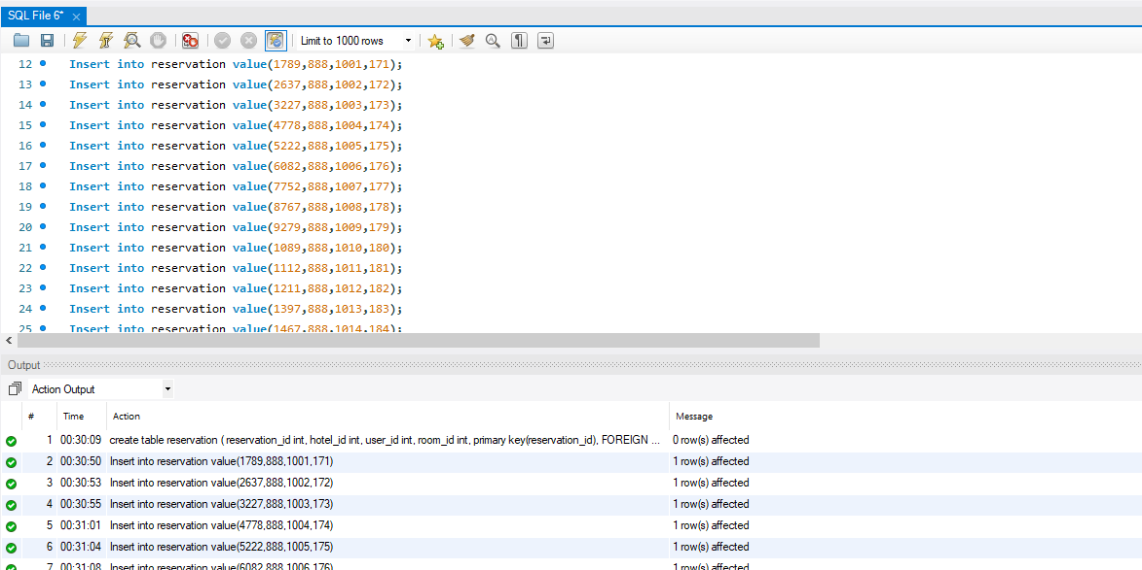

**Creating “room” table:**

create table room

(

room_id int,

hotel_id int,

capacity int,

price double,

reservation_id int,

FOREIGN KEY (reservation_id) REFERENCES reservation(reservation_id)

);

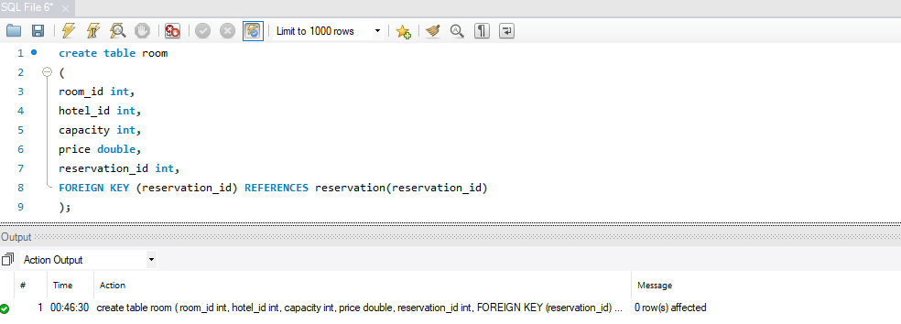

**Inserting values into “room” table:**

Insert into room value(171,888,2,1000,1789);

Insert into room value(172,888,2,1000,2637);

Insert into room value(173,888,2,1000,3227);

Insert into room value(174,888,2,1000,4778);

Insert into room value(175,888,2,1000,5222);

Insert into room value(176,888,2,1000,6082);

Insert into room value(177,888,3,1500,7752);

Insert into room value(178,888,3,1500,8767);

Insert into room value(179,888,3,1500,9279);

Insert into room value(180,888,3,1500,1089);

Insert into room value(181,888,3,1500,1112);

Insert into room value(182,888,1,500,1211);

Insert into room value(183,888,1,500,1397);

Insert into room value(184,888,1,500,1467);

Insert into room value(185,888,1,500,1513);

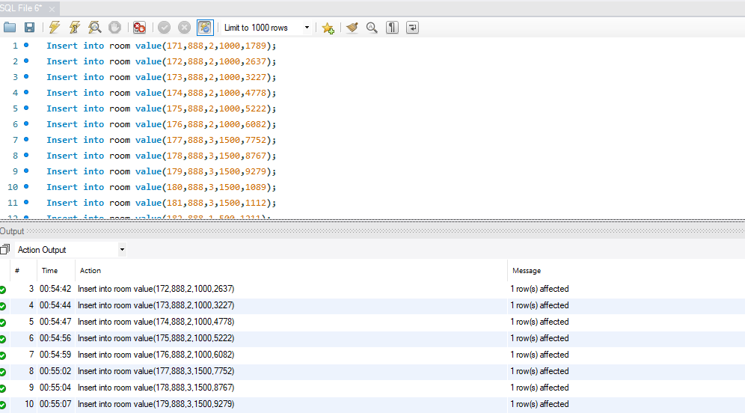

**Creating “Hotel” table:**

create table hotel

(

hotel_id int,

hotel_namevarchar(30),

location varchar(15),

reservation_id int,

FOREIGN KEY (reservation_id) REFERENCES reservation(reservation_id)

);

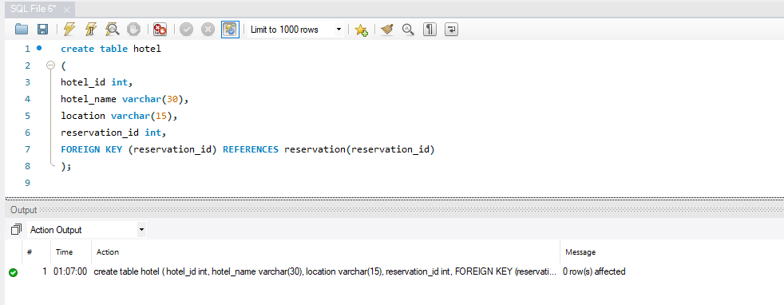

**Inserting values into “Hotel” table:**

Insert into hotel value(888,'Brown Town','Irving',1789);

Insert into hotel value(888,'Brown Town','Irving',2637);

Insert into hotel value(888,'Brown Town','Irving',3227);

Insert into hotel value(888,'Brown Town','Irving',4778);

Insert into hotel value(888,'Brown Town','Irving',5222);

Insert into hotel value(888,'Brown Town','Irving',6082);

Insert into hotel value(888,'Brown Town','Irving',7752);

Insert into hotel value(888,'Brown Town','Irving',8767);

Insert into hotel value(888,'Brown Town','Irving',9279);

Insert into hotel value(888,'Brown Town','Irving',1089);

Insert into hotel value(888,'Brown Town','Irving',1112);

Insert into hotel value(888,'Brown Town','Irving',1211);

Insert into hotel value(888,'Brown Town','Irving',1397);

Insert into hotel value(888,'Brown Town','Irving',1467);

Insert into hotel value(888,'Brown Town','Irving',1513);

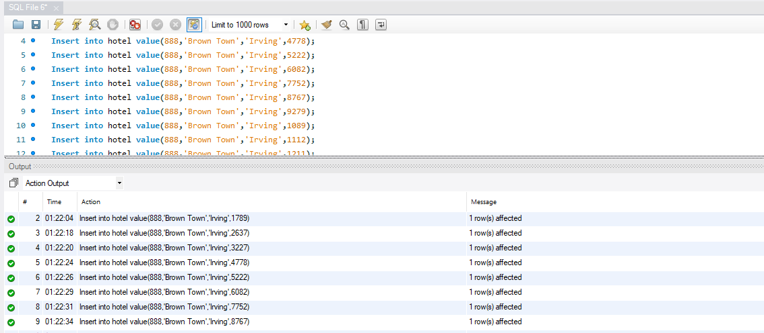

**Creating “Payment” table:**

create table payment

(

user_id int,

reservation_id int,

transaction_status varchar(10),

payment_type varchar(10),

FOREIGN KEY (reservation_id) REFERENCES reservation(reservation_id)

);

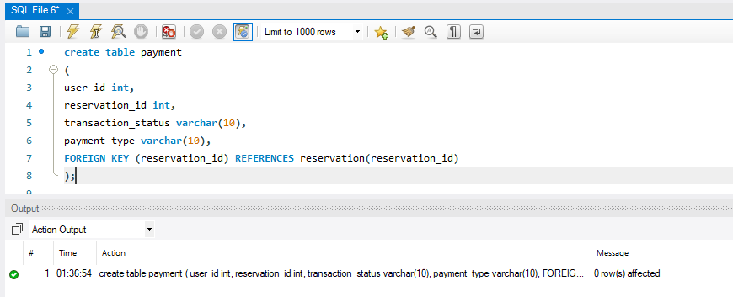

**Inserting values into “Payment” table:**

Insert into payment value(1789,1001,'success','debit card');

Insert into payment value(2637,1002,'success','debit card');

Insert into payment value(3227,1003,'success','credit card');

Insert into payment value(4778,1004,'success','google pay');

Insert into payment value(5222,1005,'success','cash');

Insert into payment value(6082,1006,'fail','credit card');

Insert into payment value(7752,1007,'fail','debit card');

Insert into payment value(8767,1008,'fail','paypal');

Insert into payment value(9279,1009,'success','apple pay');

Insert into payment value(1089,1010,'success','debit card');

Insert into payment value(1112,1011,'processing','google pay');

Insert into payment value(1211,1012,'processing','debit card');

Insert into payment value(1397,1013,'fail','apple pay');

Insert into payment value(1467,1014,'fail','google pay');

Insert into payment value(1513,1015,'success','google pay);

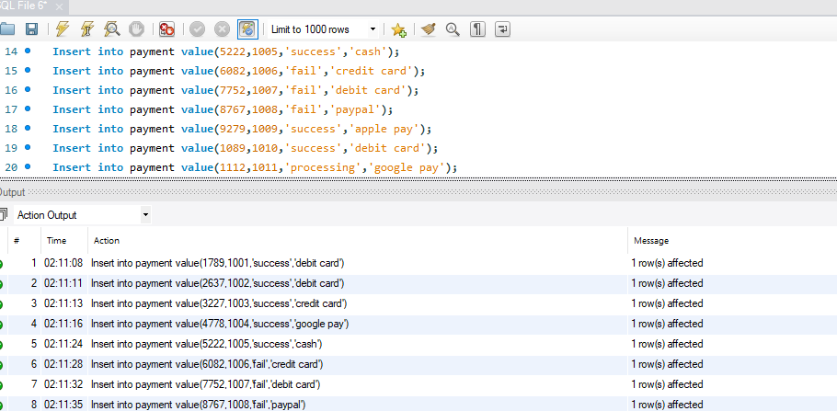

**Creating “Transaction” table:**

create table transaction

(

reservation_id int,

user_id int,

transaction_statusvarchar(15),

FOREIGN KEY (reservation_id) REFERENCES reservation(reservation_id)

);

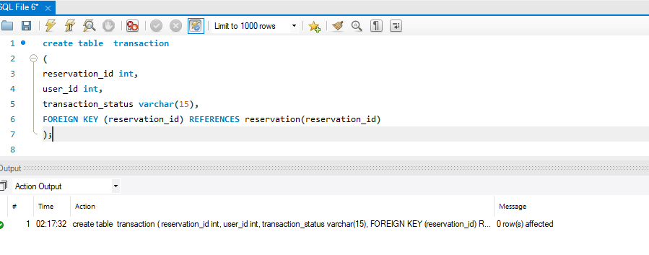

**Inserting values into “Transaction” table:**

Insert into transaction value(1789,1001,'success');

Insert into transaction value(2637,1002,'success');

Insert into transaction value(3227,1003,'success');

Insert into transaction value(4778,1004,'success');

Insert into transaction value(5222,1005,'success');

Insert into transaction value(6082,1006,'fail');

Insert into transaction value(7752,1007,'fail');

Insert into transaction value(8767,1008,'fail');

Insert into transaction value(9279,1009,'success');

Insert into transaction value(1089,1010,'success');

Insert into transaction value(1112,1011,'processing');

Insert into transaction value(1211,1012,'processing');

Insert into transaction value(1397,1013,'fail');

Insert into transaction value(1467,1014,'fail');

Insert into transaction value(1513,1015,'success');

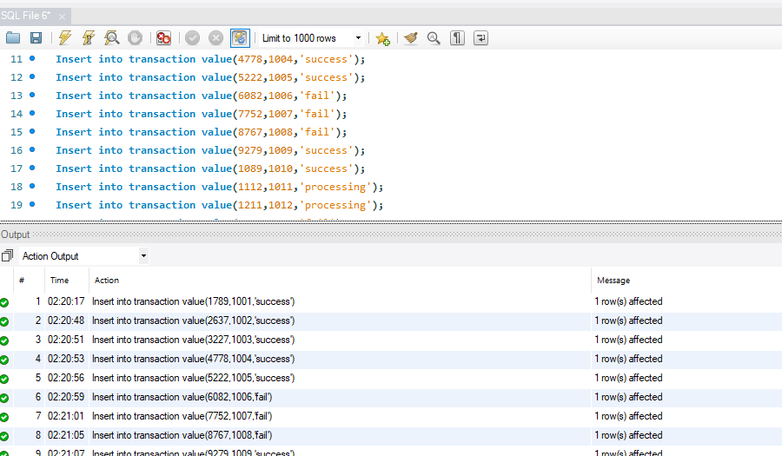

**Creating “Employees” table:**

create table employees

(

employee_id int,

employee_namevarchar(30),

hotel_id int,

reservation_id int,

FOREIGN KEY (reservation_id) REFERENCES reservation(reservation_id)

);

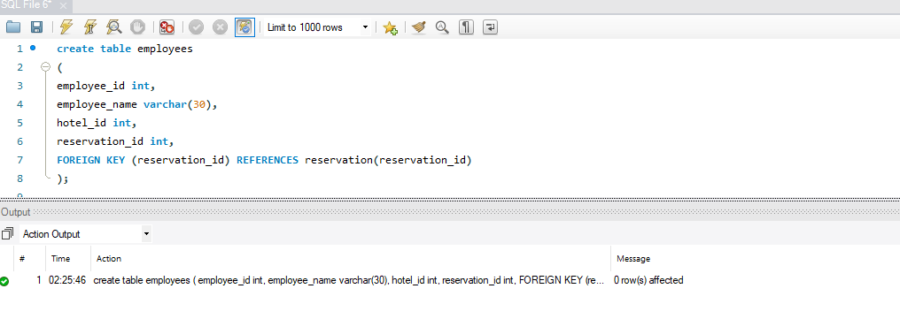

**Inserting the values into “Employees” table:**

Insert into employees value(001,'jayanth',888,1789);

Insert into employees value(002,'yashwanth',888,2637);

Insert into employees value(003,'david',888,3227);

Insert into employees value(004,'varun',888,4778);

Insert into employees value(005,'koushik',888,5222);

Insert into employees value(006,'taylor',888,6082);

Insert into employees value(007,'Caralon',888,7752);

Insert into employees value(008,'Likitha',888,8767);

Insert into employees value(009,'Kavya',888,9279);

Insert into employees value(010,'Terrisa',888,1089);

Insert into employees value(011,'Bindu',888,1112);

Insert into employees value(012,'Satwika',888,1211);

Insert into employees value(013,'Varsha',888,1397);

Insert into employees value(014,'Swetha',888,1467);

Insert into employees value(015,'Namratha',888,1513);

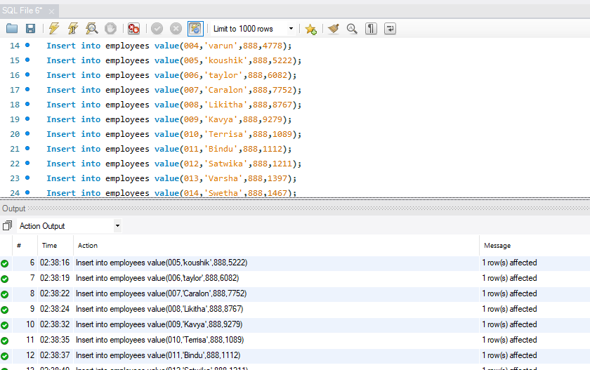

**Creating “ Room_type” table:**

create table room_type

(

room_namevarchar(30),

room_rating int,

reservation_id int,

FOREIGN KEY (reservation_id) REFERENCES reservation(reservation_id)

);

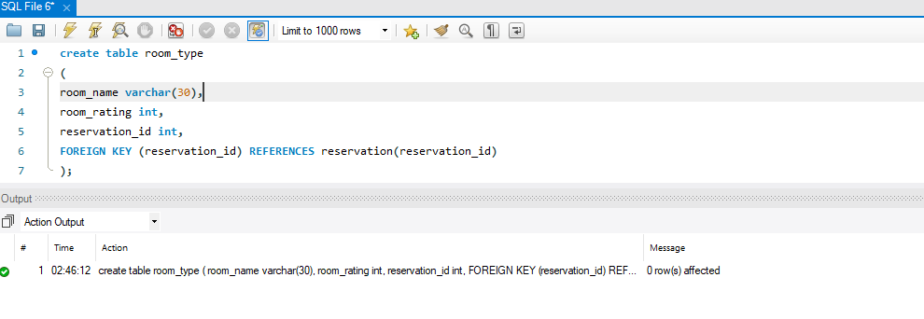

**Inserting the value into “Room_type” table:**

Insert into room_type value('deluxe',5,1789);

Insert into room_type value('deluxe',4,2637);

Insert into room_type value('deluxe',5,3227);

Insert into room_type value('deluxe',4,4778);

Insert into room_type value('vip',5,5222);

Insert into room_type value('vip',5,6082);

Insert into room_type value('vip',5,7752);

Insert into room_type value('vip',5,8767);

Insert into room_type value('deluxe',5,9279);

Insert into room_type value('deluxe',5,1089);

Insert into room_type value('Superior',3,1112);

Insert into room_type value('Superior',3,1211);

Insert into room_type value('Superior',4,1397);

Insert into room_type value('Superior',4,1467);

Insert into room_type value('Superior',4,1513);

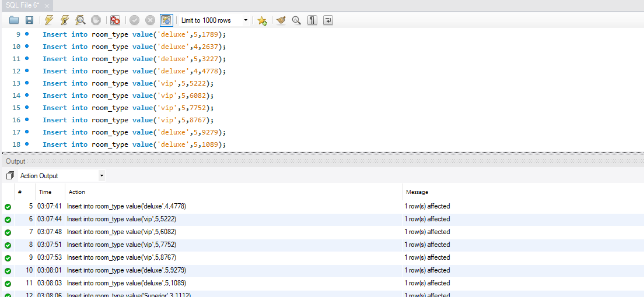

**Data Retrieval and Simple Reports**

**Select statements**

* SELECT room.*, SUM(price) OVER() AS price FROM room;

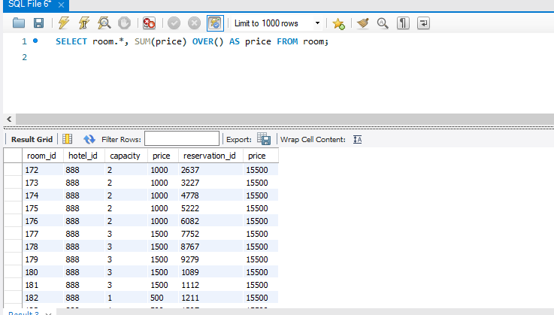

* select * from user where length(phone_number)<=10;

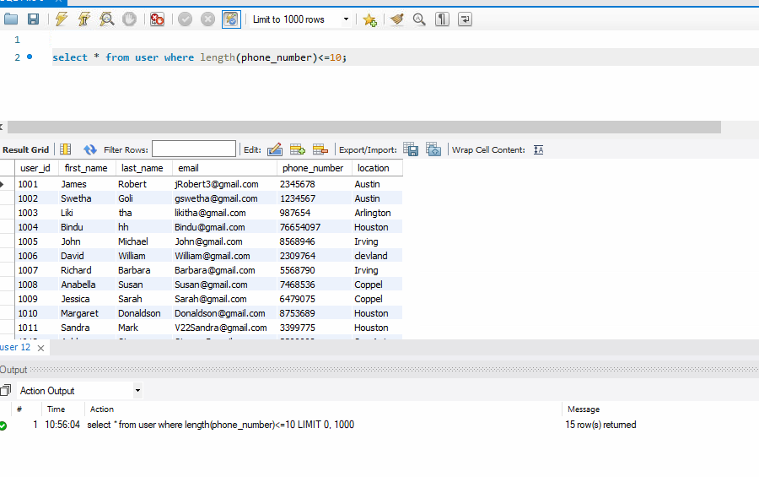

* WITH temporaryTable(avgVal) as

(SELECT avg(Price)

from room)

SELECT *

FROM room, temporaryTable

WHERE room.price > temporaryTable.avgVal;

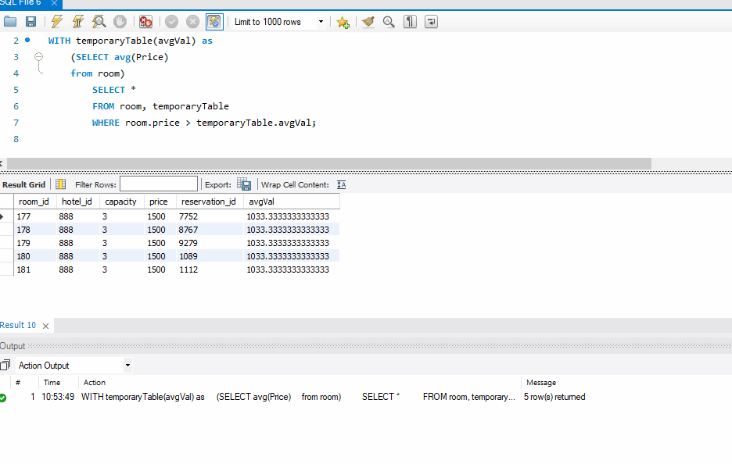

* select room_type.*,instr(room_name,'a') from room_type where instr(room_name,'s')>0;

* select * from user where regexp_like(first_name,'^S','i');

